**ACKNOWLEDGMENT**

We have taken efforts in this major project. However, it would not have been possible without the kind support and help of many individuals and organization. I would like to extend my sincere thanks to all of them.

We are highly indebted to **Dr. Vidushi Sharma** for their guidance and supervision.Her constant guidance and willingness to share her vast knowledge made us understood this project and its manifestations in great depths and helped us to complete the assigned task.

We would like to thank all the faculty members and staff of Department of Computer Science and Engineering ,SOICT, Gautam Buddha University for their generous help in various ways for completing our project.

Finally ,we would like to express our gratitiude to our beloved parents for their blessings,my friends for their help and wishes for the successful completion of this major project.

**CERTIFICATE**

**C**ertified that this minor Report titled “Network Performance Evaluation of M2M With Self Organising Cluster Head to Sink Mapping” is the bonafide work of Shweta Rani,Shivani Singh and Vishal Pandey who carried out the research under my supervision.Certified further,that to the best of my knowledge the work reported herein does not form part of any other project report or dissertation on the basis of which a degree or award was conferred on an earlier occasion on this or any other candidate.

**Date:29th March 2019 Dr. Vidushi Sharma**

**ABSTRACT**

Machine to machine communication is defined as direct communication between devices using any communication channel that can be wired or wireless. M2M supports an energy-efficient routing protocol to transmit data from cluster member (nodes) to a sink node along cluster heads in Wireless Sensor Network(WSN).Due to heavy M2M traffic network congestion can occur which is checked using load balancing solutions so that network performance can be maintained . Here we have used a Multilevel Clustering Multiple Sinks(MLCMS) with IPV6 protocol over Low Wireless Personal Area Networks(6LoWPAN) and a intensified network performance is accomplished through non-linear based optimization. Self-Organising Cluster Head to Sink Algorithm (SOCHSA) is proposed ,with the help of Discrete Particle Swarm Optimisation(DPSO) and Genetic Algorithm (GA) as Evolutionary Algorithms(EAs) to solve the network optimization problem. Here SOCHSA is tested on the basis of two criteria problems with two and three sinks. While performing with 2 sinks the average residual energy was less then as compared to three sinks were used ie about 2%.So Genetic Algorithm is used to solve the network optimisation problem.

**INTRODUCTION**

Iot has  the ability to transfer data over a network without requiring human-to-human or human-to-computer interaction.. Iot consist of millions of devices for that transmitting and receiving. M2M is considered as the core of Iot. Machine to machine is used for direct communication between devices using any communication channel that can be wired or wireless.

Key features of M2M include:

a)Low mobility

b)Packet switching

c)Time controlled data transmission

d)Monitoring events of interest

e)Low power consumption

In WSN, multiple sinks at correct locations can sharply decrease the energy use and the message transfer delay in communication. Moreover, a multiple-sink WSN has much less tendency for sink node isolation .But if there is only a single sink then heavy traffic load and packet loss can take place . The nodes present in the network should be near to the sink so that less power consumption can take place.

If network load situations occurs then it can have a bad impact on network performance as a result effective load balancing algorithm is used over here.Through load balancing algorithm the load can fairly and evenly distributed amoung resources available.

The algorithms where the nodes are arranged in clusters in the network for data transmission are termed as cluster-based methods

The aim of the project is to improve network performance by integrating an efficient routing protocol (MLCMS) and a load balancing strategy to introduce new transmission techniques while maintaining a more balanced system

MLCMS is responsible for transmission of multiple sinks and is used for selection of cluster head which could be beneficial for network enchancement.

The load balancer obtains optimum CH-Sink reconfiguration via an algorithm called SOCHSA. Once the load on any sink reaches an alarming threshold, the load balancer triggers SOCHSA algorithm.

SOCHSA algorithm hosts two evolutionary algorithms i.e. GA and DPSO to solve the load balancing optimisation problem.

A sharing node with unlimited energy is also emoployed in this model so the it can enable every CH with the ability of flexible transmission to any sink based on the CH-Sink configuration. .

**PROBLEM IDEA**

The aim of the project is to improve network performance by integrating an efficient routing protocol (MLCMS) and a load balancing strategy to introduce new transmission techniques while maintaining a more balanced system. SOCHSA algorithm is used to obtain optimum CH-Sink reconfiguration

**SYSTEM ARCHITECTURE**

Consider a network in which a sensing field is logically divided into N sections, as shown in Fig. 1,Fig. 2 ,Fig. 3 depending on the number sinks to be used.If there are two sinks the sensing field is divided into four sections( Fig. 1), if there 3 sinks the sensing field is divided into six sections(Fig. 3) .Each section consist of 3 levels. Each CH consist of a sink and nodes around it .The sensing field size is assumed to be NxN.

The proposed network model contains the following elements.

**a)** **NODES**

There are no. of nodes distributed randomly in the sensing field. The nodes present in the sensing field can be selected as a normal node or it can act as cluster.

**b) CENTRALISED SERVER**:

Server is responsible for collecting the network information like network topology, the number of CHs, Sink-CH configuration and number of active nodes so that it can identify optimum Sink-CH configuration to increase the network perfomance. The server also hosts intelligent algorithm to identify optimum CH-Sink configuration, which buzzes when the load on the sinks reaches above a threshold.

**c) SHARING SENSOR NODE**

The sharing sensor nodes are used to transmit data between the sections of the sensing field to avoid crossing of the transmission range boundaries(T.R).

**d) TRANSMISSION RANGES OF THE SENSING FIELD**

Each section is divided into three levels . At each level, there is a maximum T.R, which is the diagonal length of the level( Fig. 1) Nodes that are beyond this are unable to connect with the CHs, whereas those within the range transmit their parameters to the CH for new CH election or to the centralised node of each level initially.. Moreover, the T.Rs between a CH and the closest sharing node is considered equal to that of CHs and CH in the sensing field, as shown in Fig. 1 and Fig. 3

**TRANSMISSION RANGE FORMULAS**

The T.R of CH-to-Node is:

HCH – Node = √(𝑎)2 +(𝑏)2 (1)

The T.R of CH-to-CH or CH-to Sharing sensor node is:

HCH−CH =√(a)2 +(2∗b)2 (2)

The T.R of CH or Nodes-to-Sink is:

HCH−Sink = √ (0.5∗𝑎)2 +(3∗𝑏)2 3)

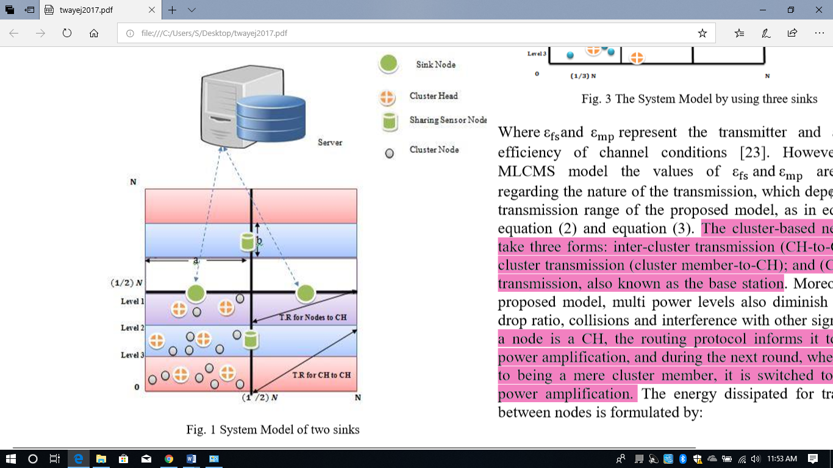

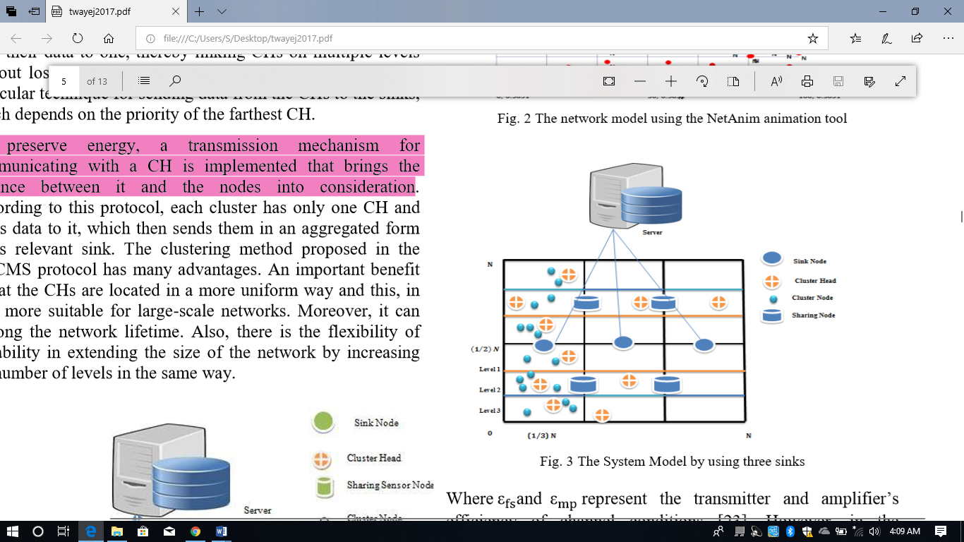

**CLUSTER HEAD SELECTION**

MLCMS routing protocol consist of two phases that are set up phase and steady state phase. The CH selection phase is present in setup phase ,CH consist of cluster nodes around it. Initially sen a Hello message is send to all the nodes at the same level ( Fig. 4). Only those nodes that comes within transmission range can receive the message and hence, send information regarding residual energy.In this phase, the node with the highest weight is elected as the CH.

The weight of the node is calculated by equation (4), which takes the residual energy, the number of neighbours and the distance to the sink . Thus, we can generate more balanced clusters by calculating the maximum W(n) are then selected as the CHs of this level.

After the CHs are selected they send the invite message to all nodes nearby within the transmission range.After that these nodes send there data to the cluster head. Ihe CH’s energy is checked regularly, and if it is less than 25% of its residual energy, it should be changed. The new CHs for each level will be selected by the old CH, sending a request to all related nodes’ about their residual energy, the number of neighbours and their (x,y) position so as to measure their distance from their sink.

The one that has maximum, W(n), will be awarded the role of new CH for that level.

**EQUATIONS FOR CALCULATING THE WEIGHT OF NODES:**

W(n) = 𝜛1𝐸(𝑛) +𝜛2N(n)−𝜛3D(n) (4) 0≤ 𝜛1,𝜛2,𝜛3 ≤ 1

where

𝜛1 +𝜛2 +𝜛3 = 1

𝜛1,𝜛2,𝜛3 = Effect factors

𝐸(𝑛) is the residual energy of node n

𝑁(𝑛) is the number of neighbors of node n

𝐷(𝑛) is the distance between node n to the sink

E(n) = Rn(t) /Ein (5)

Residual energy is the remaining energy divided by the initial energy and their position (x, y).

Rn(t) = Remaining energy of node n at time (t)

Ein = Initial energy of node n.

D(n) = √(X2 −X1)2 +(Y2 −Y1)2 (6)

The priority levels or weights selected for (4) are based on the Rank Order Centroid (ROC) method The priorities of each function are taken as an input and converted into the weight for the function. The following formula does the conversion:

ϖi = (1/ F)∑ (1/ n) (7)

where

F =Number of functions (E(n),N(n)and D(n))

wi= Weight of the ith function. E(n),

**PRIORITY CALCULATION**

Ist Ranks

Weight = (1/ 1+ 1/ 2+1 /3 ) = 0.6 =E(n)

2nd Rank

Weighted =(1/ 2+1/ 3 ) = 0.2 = N(n)

3rd Ranked

Weighted = (1/ 3 ) = 0.1 = D(n)

The second phase is the steady-state phase, which is responsible for forwarding the information to the sink. It is the crucial factor of the model, which is the CH at level three in each quarter and cannot connect directly to a sink. It should be attached to that at level two, but if there is no CH at this level, it can connect directly to a sink.

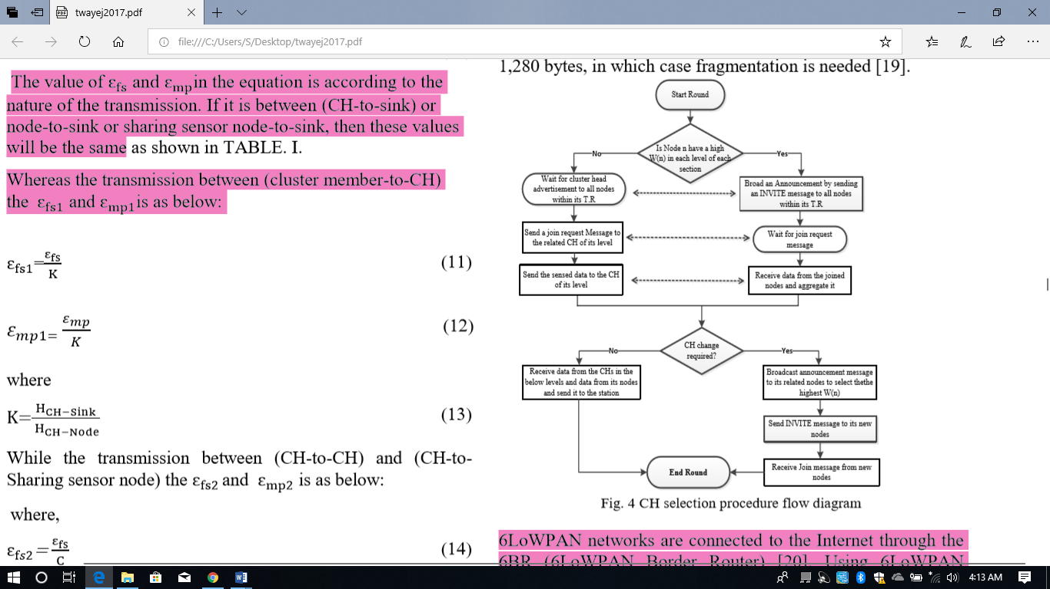

,m.